QUESTION:

1. Use the table tag to design given image [Click here](https://www.bapugraphics.com/assets/img/port_upload_dir/table-4.jpg).

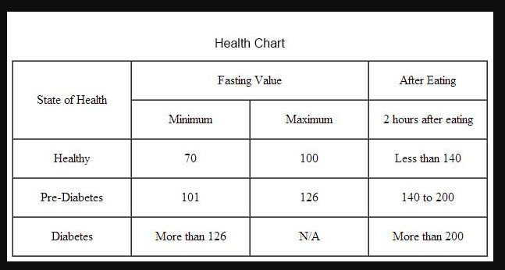

CODE:

<!DOCTYPE html>

<!--HTML 5-->

<html lang="en">

  <head>

    <meta charset="UTF-8" />

    <meta http-equiv="X-UA-Compatible" content="IE=edge" />

    <meta name="viewport" content="width=device-width, initial-scale=1.0" />

   <!-- <link rel = "stylesheet" href="style.css">   -->

    <title>Document</title>

    <style>

      table, th, td {

        border: 1px solid black;

        border-collapse: collapse;

        text-align:center;

      }

      </style>

  </head>

  <body>

    <h4>Health Chart</h4>

    <table cellspacing="4" cellpadding="4">

      <tr>

        <td rowspan="2">State of health</td>

        <td colspan="2">Fasting value</td>

        <td>After eating</td>

      </tr>

      <tr>

        <td>Minimum</td>

        <td>Maximum</td>

        <td>2 hours after eating</td>

      </tr>

      <tr>

        <td>Healthy</td>

        <td>70</td>

        <td>100</td>

        <td>less than 140</td>

      </tr>

       <tr>

        <td>Pre-diabetis</td>

        <td>101</td>

        <td>126</td>

        <td>140 to 200</td>

      </tr>

       <tr>

        <td>Post-Diabetis</td>

        <td>More than 126</td>

        <td>N/A</td>

        <td>More than 200</td>

      </tr>

    </table>

  </body>

  <!-- lodash.js is downloaded and placed in current folder -->

  <script src="./lodash.js"></script>

  <script src="./script.js"></script>

</html>

OUTPUT:

